VERSION DESCRIPTION DOCUMENT (VDD)   
FOR   
MARVIN TESTER

Version

17/01/2018

Prepared for:

Redler Technologies

Prepared by:

Redler Technologies Ltd.

**VERSION DESCRIPTIOMENT (VDD)**

**FOR**

**MARVIN TESTER**

Author:

J.Haim

____________________________

Redler Technologies Ltd. 17/01/2018

Approved: Accepted:

Nissim Evgeny Altshuler

___________________________ _____________________________

[designator] date [Software Project Manager] date

RECORD OF CHANGES

|  |  |  |  |  |
| --- | --- | --- | --- | --- |
| Revision Number | Release  Date | Description | Total  Pages | Author |
| 0.1 | 7.3.18 | Original issue | - | J.H |
|  |  |  |  |  |
|  |  |  |  |  |
|  |  |  |  |  |
|  |  |  |  |  |
|  |  |  |  |  |
|  |  |  |  |  |
|  |  |  |  |  |

**TABLE OF CONTENTS**

1. SCOPE 5

1.1. Identification 5

1.2. System Overview 6

1.2.1. General 6

1.2.2. CSCI Overview 6

1.3. Documentation Overview 6

APPLICABLE DOCUMENTS 7

1.4. Contractual Documents 7

1.5. Customer Documents 7

2. Version Description 8

2.1. Inventory of Materials Released 8

2.2. Inventory of CSCI Contents 8

2.3. Bibliography of Reference Documents 8

2.4. Summary of Changes 8

2.5. Installation Instructions 8

Appendix A - List of Files 9

Appendix B - Operating System 10

Appendix C – MARVIN TESTER OSW Application Software Installation 11

1. Driver instruction Installation 11

1.1 Software installation 11

**LIST OF TABLES**

Table 1: UUT and Self Test feature of the MARVIN Tester 5

# SCOPE

## Identification

This Version Description Document (VDD) releases the Computer Software Configuration Item (CSCI) abbreviated MARVIN TESTER, which is the software for testing the units listed bellow:

|  |
| --- |
| EBAY - 95 |
| AHU - 47 |
| AHU - 63 |

Table : Marvin tester UUT feature

The directories of the CSCI are shown in Figure 1 below:

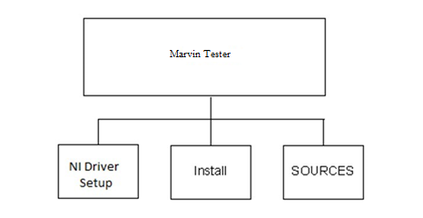

Figure – MARVIN Tester Directory Structure.

## System Overview

### **General**

Automatic Test Procedure of the MARVIN is based on its manufacturer acceptance test procedure.

### **CSCI Overview**

N/A.

## Documentation Overview

This VDD describes the test software forming this Computer Software Configuration Item (CSCI).

Section 2 of this document includes the referenced documents.

Section 3 includes the detailed description of the version being released; the inventory of materials released and CSCI contents, changes and installation instructions.

APPENDIX A contains a list of files for this software version.

APPENDIX B Operating System (OS).

APPENDIX C MARVIN TESTER OSW Application Software Installation.

# APPLICABLE DOCUMENTS

## Contractual Documents

None.

## Customer Documents

None.

# Version Description

## Inventory of Materials Released

The following MARVIN TESTER software package release includes the following materials:

* This document.
* The executable/application files (EXE)
* NI drivers installation – SETUP.exe
* Entire Package – MARVIN.zip
* List of files - MARVINFilesName.txt

## Inventory of CSCI Contents

None.

## Bibliography of Reference Documents

Refer to Section 2.

## Summary of Changes

See page 3.

## Installation Instructions

See Appendix C.

# Appendix A - List of Files

**Version 2.0**

Refer to the list of files deposited in with the entire software package.

(The files list is in a “.txt” file: " FileList.txt ")

# 

# Appendix B - Operating System

The MARVIN TESTER application runs under WINDOWS 7 32 Bit.

Must have Microsoft Office with a valid key registration.

The OS and Microsoft Office should be already installed in the PC.

# Appendix C – MARVIN TESTER OSW Application Software Installation

# Driver instruction Installation

## Software installation

* + 1. The installation is for Windows 7 computer with Microsoft Office 2013 or higher which is already installed.
    2. Insert MARVIN DRIVER Disk to computer.
    3. Create folder C:\Temp.
    4. Copy the MARVIN Tester setup folder from the Disc to C:\Temp folder.
    5. Double click on C:Temp\MARVIN Tester setup\Volume\setup.exe (Figure 1).

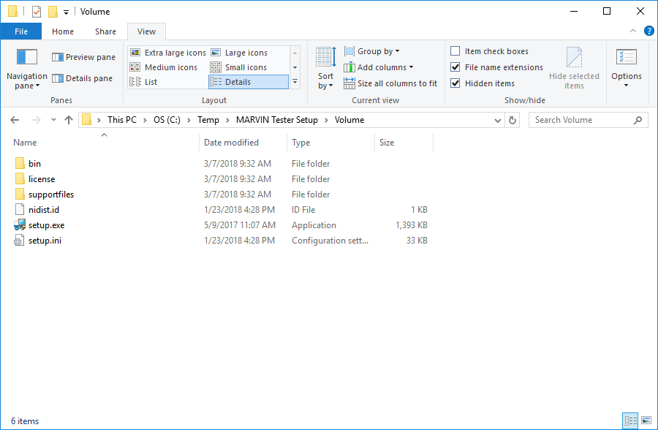

Figure 1: Installer Folder

* + 1. Verify the following screen appears and click “Yes”:

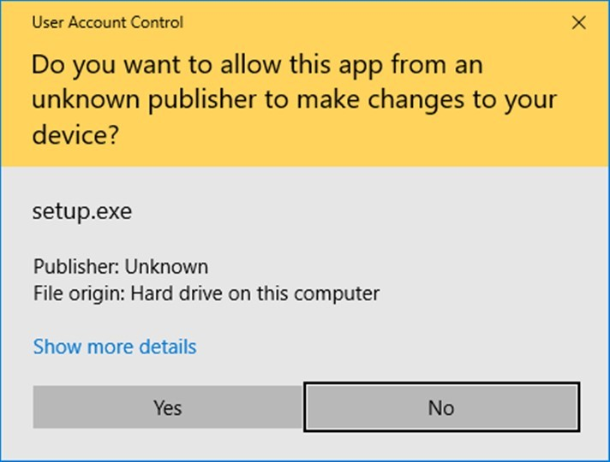

* + 1. Please wait while the installer initialized (Figure 2).

The installer initialization window may appear during a short time.

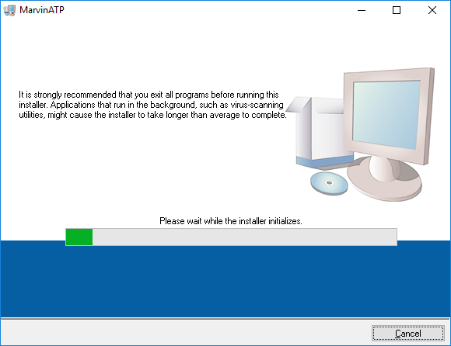

Figure 2: Installer initialization

* + 1. Press Next in Destination Directory window (Figure3).

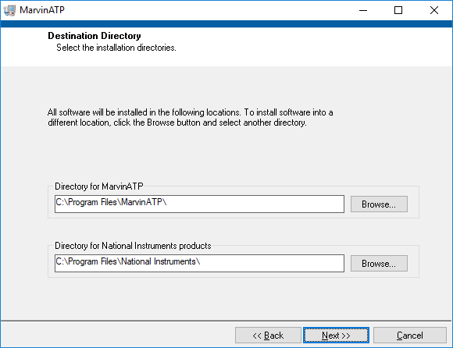

Figure 3: Destination Directory window

* + 1. License Agreement

Please accept all License agreements, then press “Next”.

The license agreement window can be different between each computer.

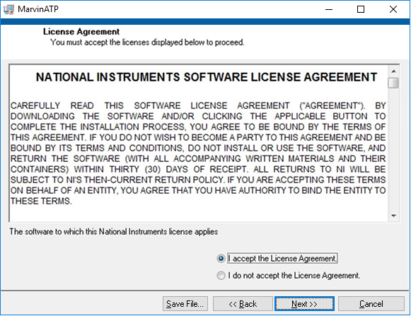

Figure 4: License agreement

*If you perform a reinstallation, the license agreement window may not appear.

* + 1. The figure bellow can be different between computers, depends of the National Instrument program which are installed in your PC, press Next (Figure 5).

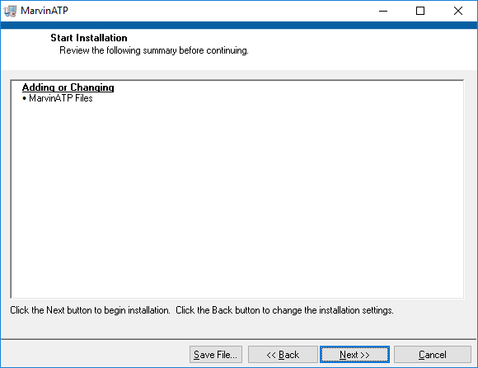

Figure 5: List of the new programs

*If you perform a reinstallation, the programs list window may be different.

* + 1. Please wait for end installation.

The loading process takes approximately half hour, depend of the computer type.

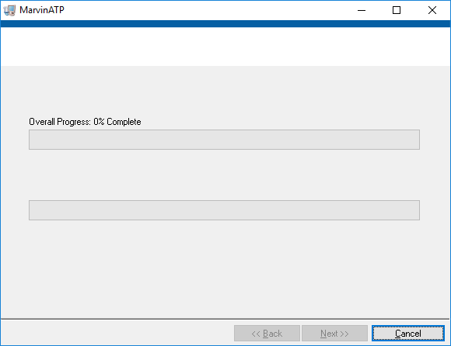

Figure 6: Installation window

* + 1. Press Next in Installation Complete window.

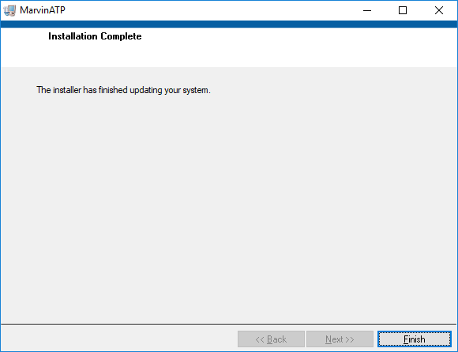

Figure 7: Installation Complete window

* + 1. Even if there is no indication to restart your computer, you should restart your computer to ensure a good work of the new installed programs.